This lecture is about standard directory structure.

1. Best way is to show you a quick example and ask you a question.
2. Maven relies upon “convention over configuration” theory.”  
   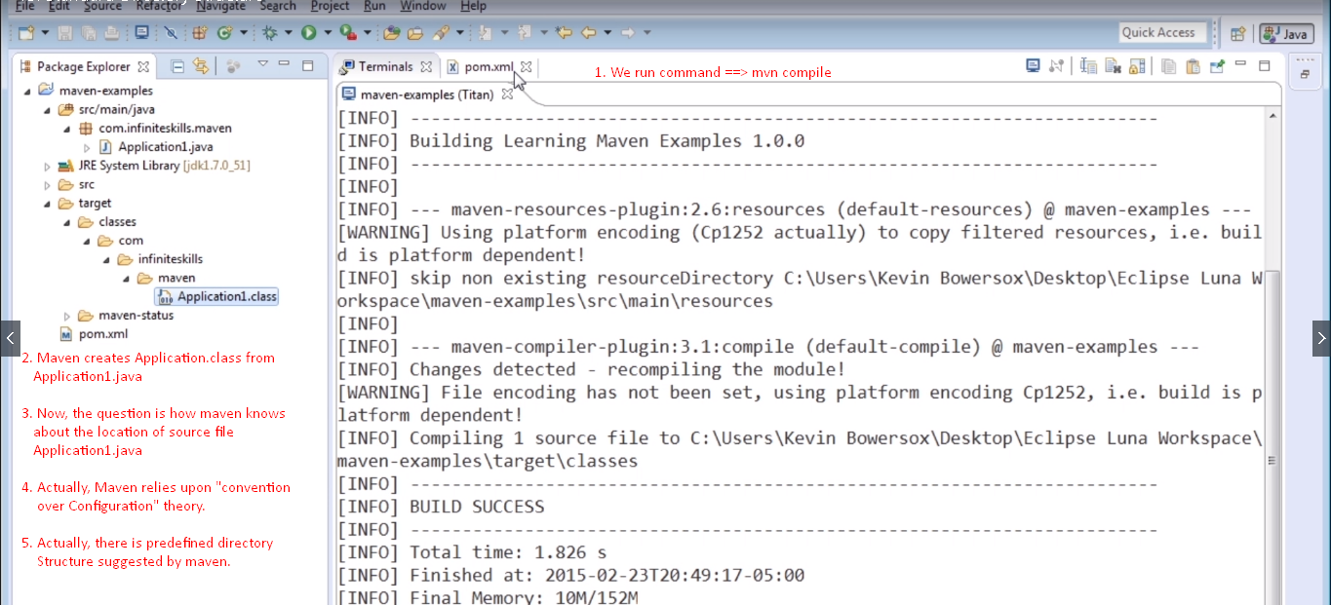
3. So instead of specifying the location of java source files, we put those into predefined locations that maven uses as standard.   
   This is known as Maven Standard Directory Layout: 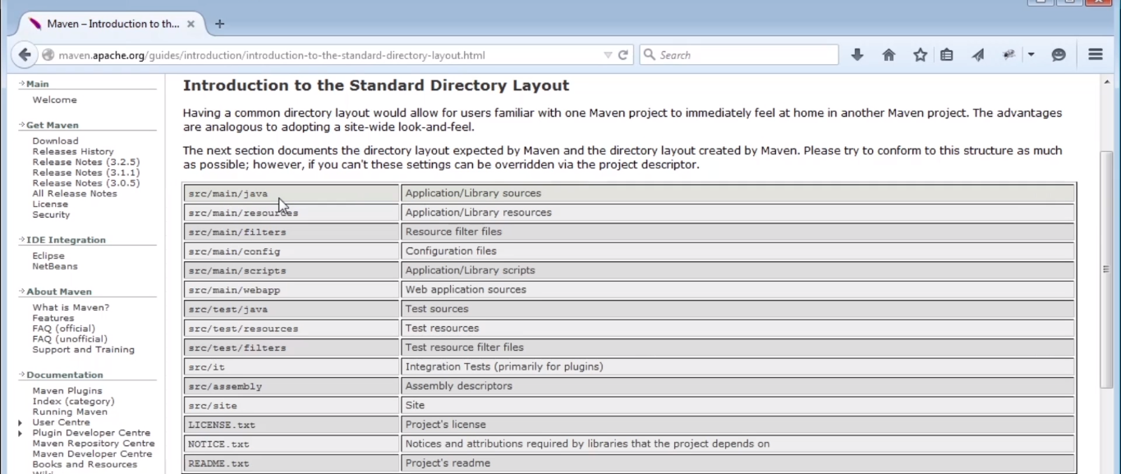
4. **How to change the default standard directory structure?**
   1. Maybe you’re working on legacy code so need to change directory structure.
   2. You can do this by specifying the configuration in pom.xml file.
   3. **NOT RECOMMENDED TO DO THAT IF YOU’RE WORKING ON NEW PROJECT**.
   4. 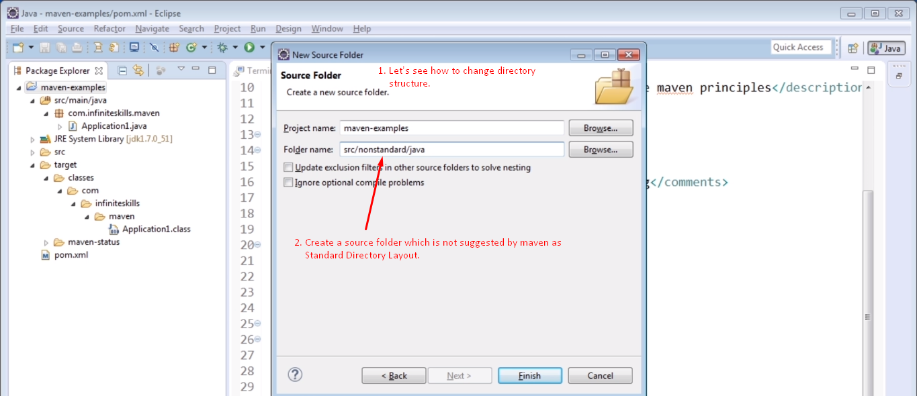
   5. 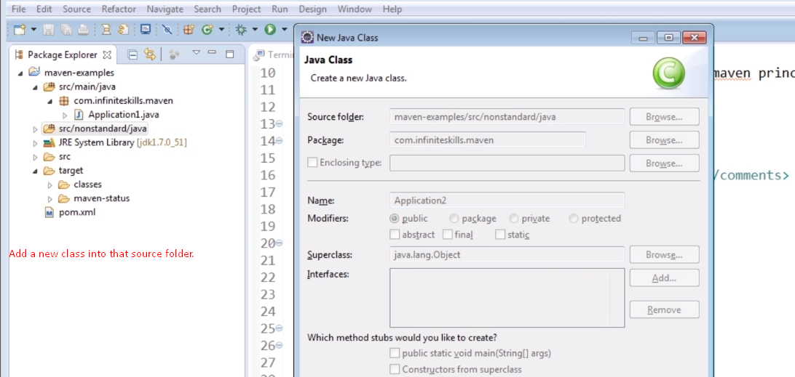
5. 